UK Safety Alert

Suspension Failure Komatsu HD405-6 Dumper Truck

Details of the Incident
The operator of a Komatsu Dump Truck (Model HD405-6) had a lucky escape when the hydraulic front suspension ram became detached from its locating socket causing the wheel to dislodge then turn under the truck.
Investigation revealed that the failure was due to the bolts in the securing plate becoming detached and the plate falling off, leaving the hydraulic front suspension ram unsecured. As the truck travelled over the rough terrain of the quarry, it is thought the ram lifted from its socket and, as the weight dropped back onto the ram, it missed the socket. This caused the wheel to push out and twist the suspension ram and its top mounting bracket resulting in substantial damage to the truck. Fortunately the machine was unloaded and travelling at low speed, at the time of the incident, had it been loaded and travelling faster the outcome may have been far more severe.

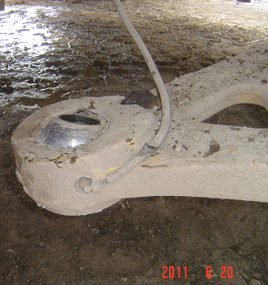
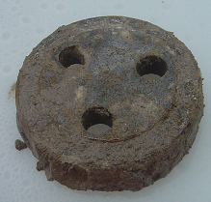
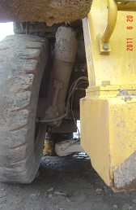
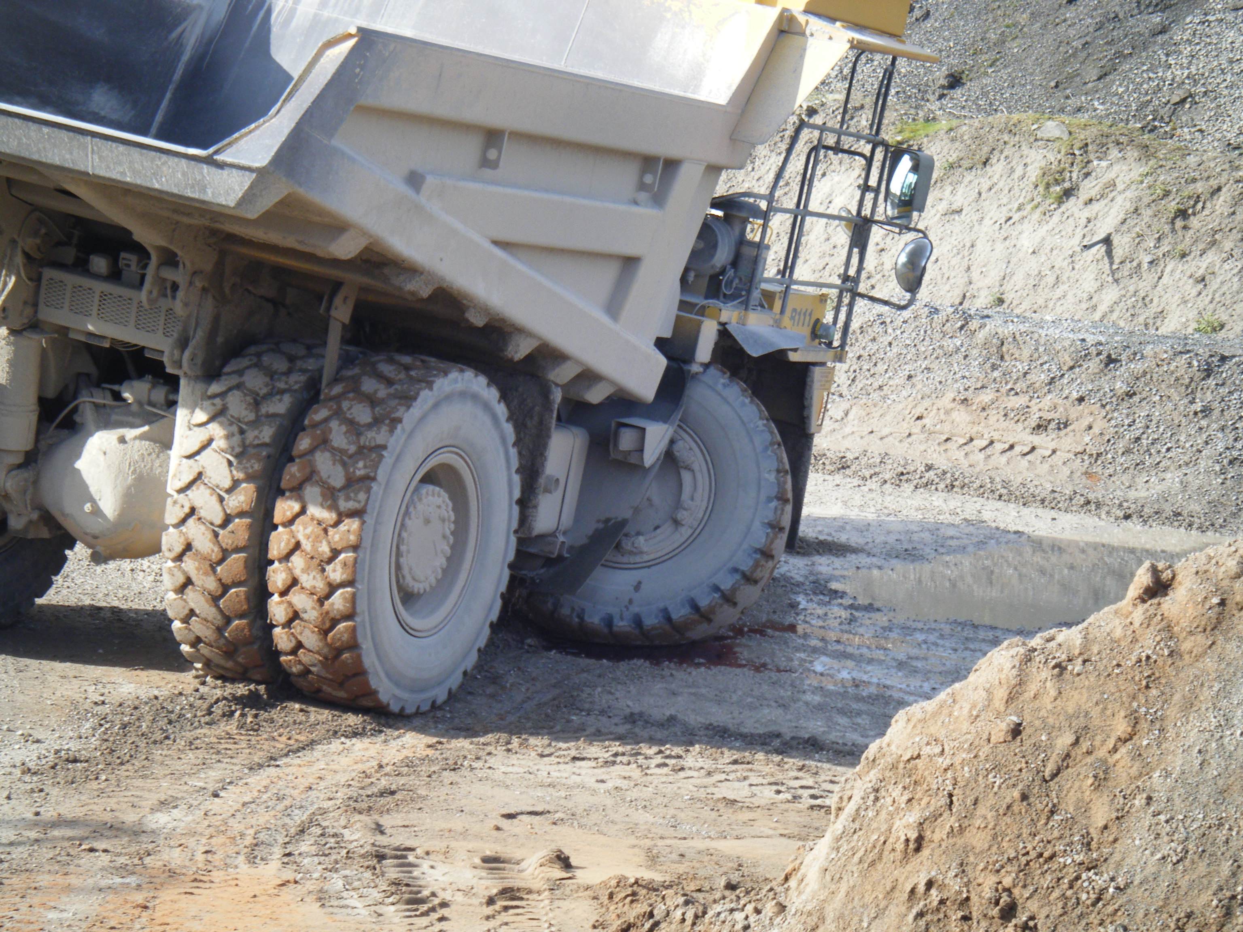
Socket
Securing Plate

Learning Points
The manufacturer’s service schedule states that the failed securing bolts should be inspected at service intervals and changed at 15,000 hours. The machine in question had covered around 12,000 hours and whilst a 500 hour interim service had recently been completed it was overdue and had been undertaken by another contractor and not Komatsu.
- The securing bolts should be checked at each service. Are all service check requirements fulfilled? Do the service records indicate what has been done?
- The servicing of the machine was not carried out by a contractor approved by Komatsu. Do you ensure that all personnel that service equipment, including mobile plant, are competent and follow the manufacturer’s guidelines?
- The previous service carried out prior to the incident, was overdue. Do procedures and monitoring regimes ensure all equipment servicing is undertaken at the required intervals?

